# Starting condition investigation

Aim of paper/short communication: show how the starting condition of a simple age-structured model can affect B0 based reference points under a range of factors. Hopefully provide some advice or insight into this common phenomenon.

# Introduction

Many fisheries worldwide have experienced commercial exploitation prior to the establishment of reliable observational time-series. In some extreme cases, reliable observational time-series commenced centuries after the onset of initial exploitation e.g., Atlantic cod (Schijns et al. 2021). This characteristic of commercial fishing prior to reliable monitoring can lead to uncertainty in the starting conditions of stock assessment models and flow through into related reference points (Punt et al. 2003, Punt et al. 2001). This affect is expected to be compounded when considering finer spatial scales, as historical data is frequently recorded at lower spatial resolution. Developing a spatially-explicit stock assessment for sablefish in the Gulf of Alaska was the motivation for this research. We found during model development that reference points were sensitive to the assumptions that affected initial conditions.

Due to differences in life-histories, catch histories, institutional inertia and data availability, there are multiple parameterizations and assumptions for the initial condition in stock assessments around the globe and even within jurisdictions (Li 2021). Given this variability in methodology, we conducted this simulation which focused on the initial condition assumptions for age-structured stock assessments and factors that may interact with initial condition and assessment outcomes.

# Methods

We refer to the period of low to no data as the “historical period” and the period with reliable data as the “data period”. In general, there are two approaches for configuring the initial conditions in age-structured stock assessments:

1. Choose a model start year close to unfished (pre-exploitation) conditions at the beginning of the historic period, historical catch is imputed for the historical period and stock dynamic assumptions required such as for the recruitment dynamic
2. Choose a model start year at the start of the data and estimate the initial age structure for the model when data is available

The first approach has the disadvantage of requiring catch to be known with a high degree of certainty over the historic period. However, historical catch histories can be contentious and uncertain (Pauly & Zeller 2016, Simmons et al. 2016). The second approach is often preferred (Punt 2023, Punt et al. 2001), but in practice, these initial parameters can be difficult to estimate (Roberts & Dunn 2017) which can lead to large uncertainty in unfished spawning biomass () and related reference points, or at worst unstable assessment models.

This simulation explores factors including life-history, length of observational time series, first year of data relative to depletion level of the stock and varying rebuilding trajectories during the data period. We focus on the estimation of and depletion / which is commonly used as an indicator for overfishing.

## Simulation

This simulation assumed the OM and EM had the same observation and process dynamics models. The EM differed from the OM in the initial conditions or catch assumptions during the historical period. The following list factors that are investigated in a fully nested factorial simulation design.

OM Factors

* Life-history – fast, medium, slow (Table 1) . These life-histories were taken from Wetzel & Punt (2016), but averaged the parameters over sex from that original paper for simplification.
* Initial depletion at the end of historic period
  + 100
  + 75
  + 50
  + 25
* F-trajectories during data period.
  + Apply a constant F that is expected to achieve B50%
  + Apply a constant F that is expected to achieve B35%
  + Apply a constant F that is expected to achieve B20%

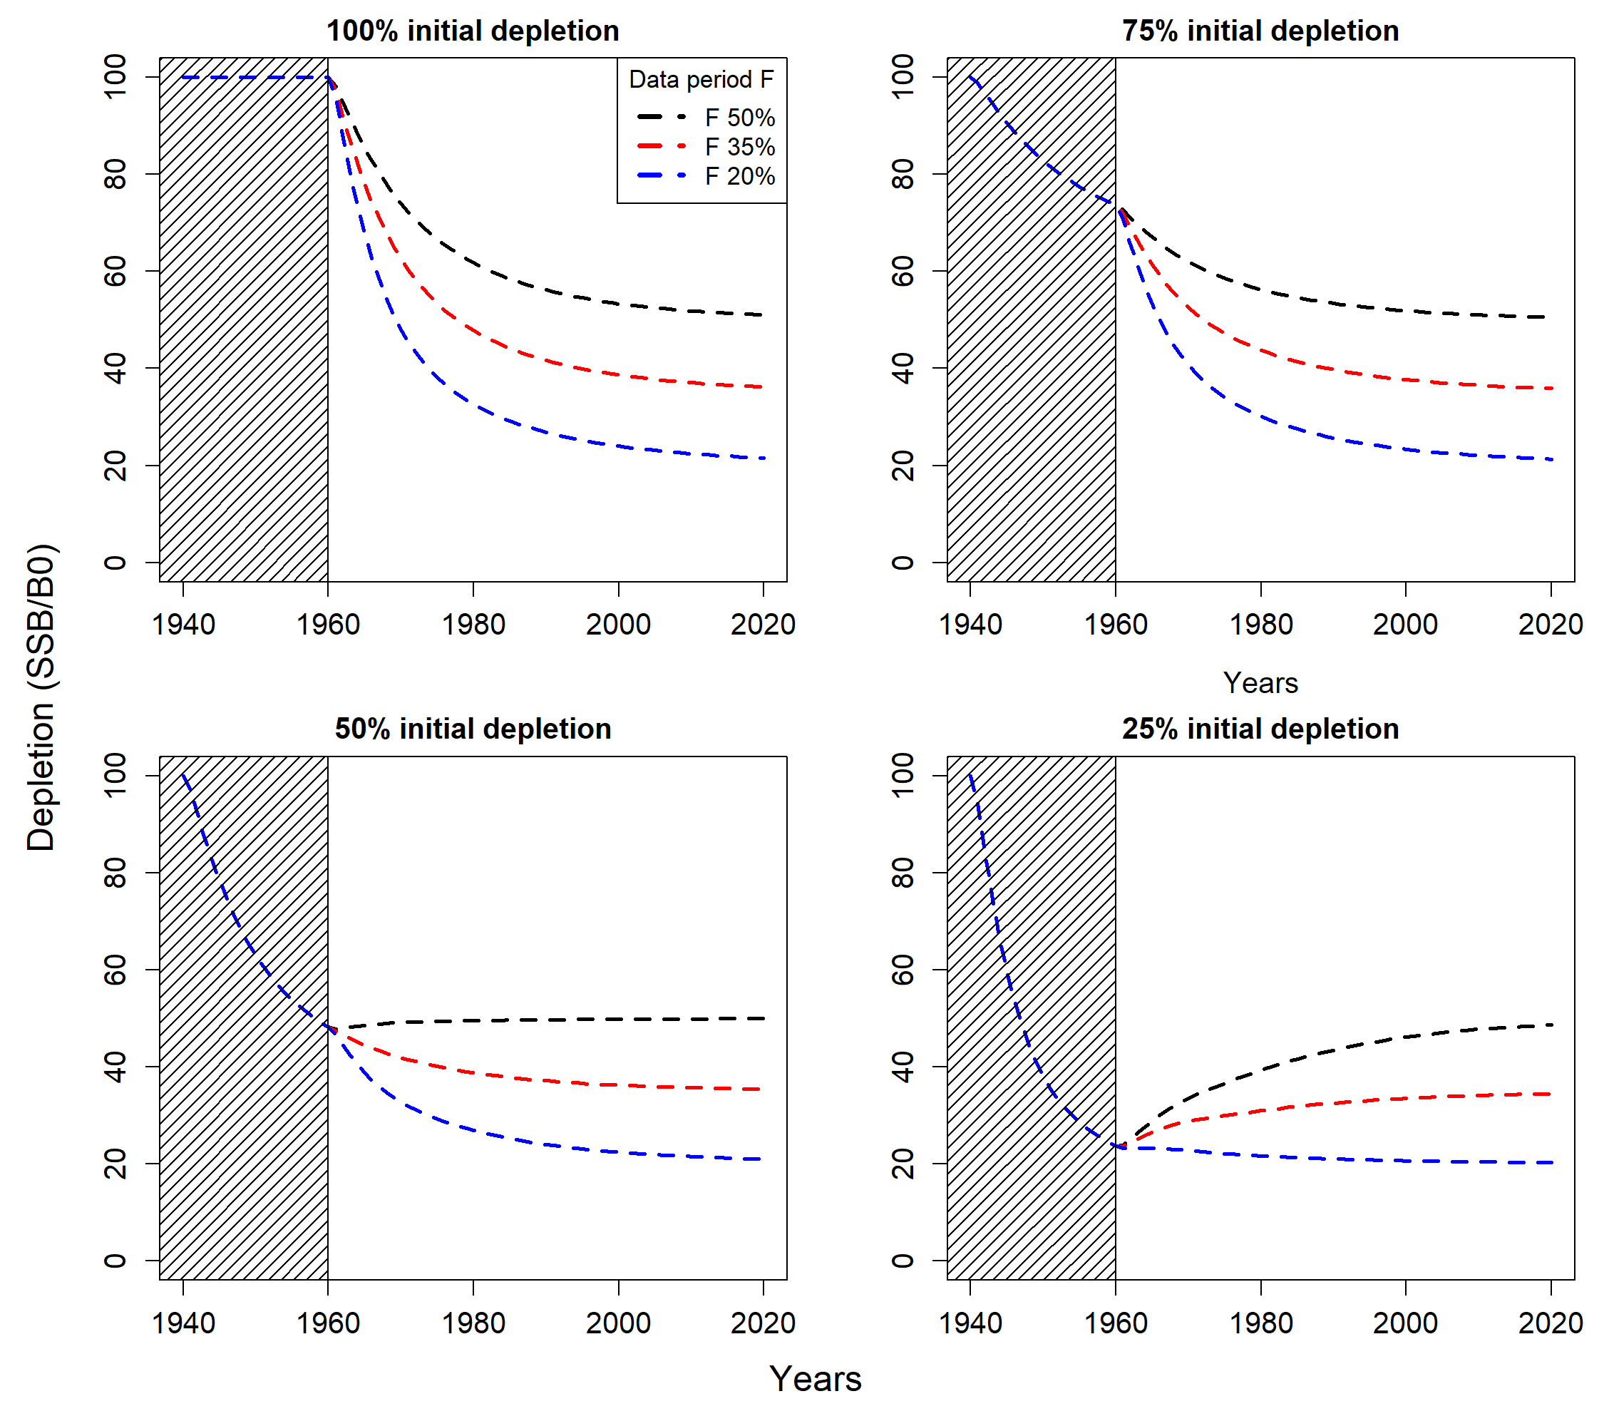

Figure : Depletion from different OM settings with equilibrium recruitment (R0 each year). Grey shaded area indicates the “historic period”. Each panel illustrates a different initial depletion level at the beginning of the “data period”, and different colored lines highlight different rebuild rules during the “data period”.

* Sensitivity run for a single OM scenario to see the effect
  + Data quality - increased precision over time
  + Double or half precision runs
  + Frequency - annual, triannual
  + Presence of a stock recruit relationship (Questionable whether this is a significant factor. I feel if the stock is depleted so that the SR kicks in it may be very informative on B0,R0). Consider that the signal will be tied to Sigma R, signal vs variance.

EM Factors

* Terminal year 1980 vs 2020
* Initial condition assumptions EM 1-3

Table : OM and EM combinations for a given life-history

|  |  |  |
| --- | --- | --- |
| OM scenarios (these will be repeated for each life-history x3) | | |
| Label (OM_initial_rebuild) | Initial depletion | Constant F |
| OM_100_50 | 100% | 50% |
| OM_100_35 | 100% | 35% |
| OM_100_10 | 100% | 10% |
| OM_75_50 | 75% | 50% |
| OM_75_35 | 75% | 35% |
| OM_75_10 | 75% | 10% |
| OM_50_50 | 50% | 50% |
| OM_50_35 | 50% | 35% |
| OM_50_10 | 50% | 10% |
| OM_25_50 | 25% | 50% |
| OM_25_35 | 25% | 35% |
| OM_25_10 | 25% | 10% |
| EM scenarios (these will be applied to each OM scenario) | | |
| Label (EM_assumption_terminal) | Initial conditions | Terminal year |
| EM_self_1980 | EM1 | 1980 |
| EM_under_1980 | EM1a | 1980 |
| EM_over_1980 | EM1b | 1980 |
| EM_F_init_1980 | EM2 | 1980 |
| EM_F_n_init_1980 | EM3 | 1980 |
| EM_self_2020 | EM1 | 2020 |
| EM_under_2020 | EM1a | 2020 |
| EM_over_2020 | EM1b | 2020 |
| EM_F_init_2020 | EM2 | 2020 |
| EM_F_n_init_2020 | EM3 | 2020 |

### Estimation model in simulations

EM 1 unfished age structure

When EM1 formulation is assumed, catch is required between the unfished period and data period. Three catch scenarios are explored with the EM1 formulation. The first assumed catch was known perfectly (EM1) the second assumed catch was constantly underreported during the historic period by 25% (EM1a) and the third assumed catch was over-reported by 25% during the historic period (EM1b)

EM 2 estimate just

Where, and where is an estimable parameter and is a selectivity for age . When only a single fleet is modeled the choice of can be more straightforward when compared to models with multiple fleets, and assumptions are needed that reflect the exploited age-structured during the initialization period.

EM 3 – estimate initial age deviations ( and

This assumes that initial age-deviations are from the same distribution as the recruitment deviations. It could be assumed that the initial age-deviations have their own estimable variance but for simplicity we assumed a pooled distribution with recruitment deviations.

### Performance metrics

The Relative error (RE) and median absolute relative error () were used to characterize both bias and precision simultaneously in B0 and depletion (). For depletion performance metrics we displayed the maximum and minimum of these median relative errors across all years to characterize the range of bias in each scenario. The relative error for parameter model quantity is calculated

We displayed the for the

### Simulation

Table : Life history parameters used in the simulation.

|  |  |  |  |
| --- | --- | --- | --- |
|  | Fast (flatfish) | Medium | Long |
| Age plus group | 30 | 50 | 100 |
| Natural Mortality (M) | 0.15 | 0.08 | 0.05 |
| Steepness (h) | 0.85 | 0.65 | 0.50 |
| Maximum length ( | 58 | 34 | 64 |
| Growth coefficient () | 0.133 | 0.115 | 0.047 |
| Body weight | | | |
| Growth coefficient () |  |  |  |
| Growth coefficient () | 3.50 | 3.17 | 3.17 |
| Maturity (logistic) |  |  |  |
| Age at 50% maturity | 4.5 | 9 | 19.5 |
| Width for 95% mature | 1.8 | 3.2 | 6.4 |
| Fishery selectivity (logistic) | | | |
| Age at 50% selective () | 7 | 7 | 15 |
| Width for 95% selective () | 2 | 5 | 7 |
| Survey selectivity (logistic) | | | |
| Age at 50% selective () | 5 | 3 | 10 |
| Width for 95% selective () | 2 | 2 | 7 |
| Survey catchability () | 0.2 | 0.2 | 0.2 |
| Survey AF sample size () | 500 | 500 | 500 |
| Survey index standard deviation () | 0.15 | 0.15 | 0.15 |
| Fishery AF sample size () | 500 | 500 | 500 |
| Catch standard deviation () | 0.02 | 0.02 | 0.02 |

### Results

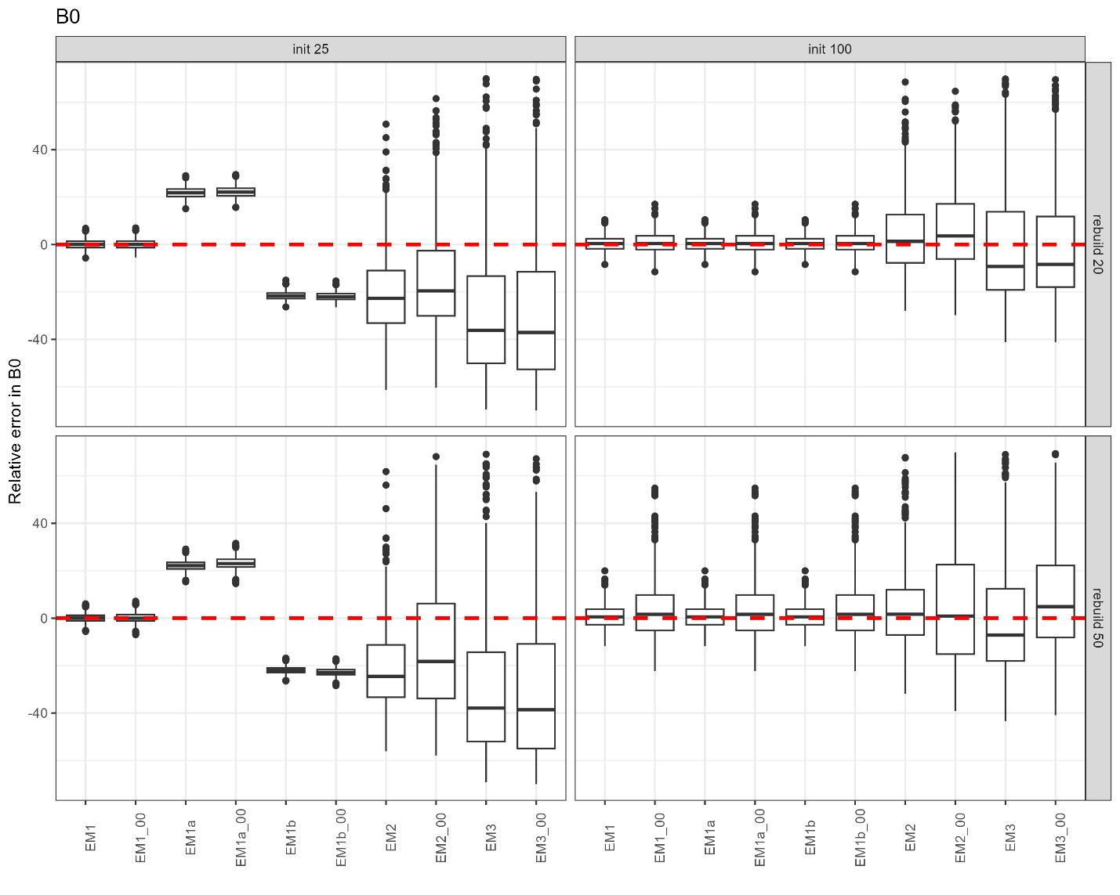

Figure : Relative error B0.

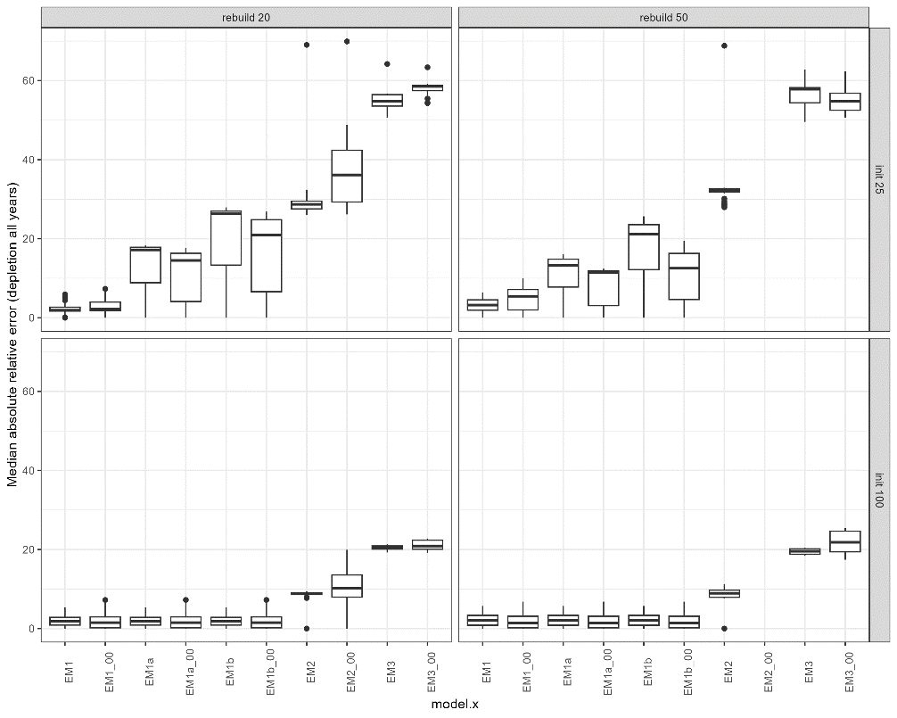

# Appendix

### Operating Model

#### Process dynamics y > 1

Where is the annual recruitment for age 1 which follows the Beverton-Holt stock recruitment relationship based on the steepness formulation from (**get mace and doonan reference**)

is the steepness parameter, is the spawning stock biomass in year , is the long term average unfished recruitment, is the spawning biomass that results from and applying only natural mortality, and are annual recruitment deviations which have the following penalty applied to the joint objective function,

Spawning biomass is calculated as,

Where, is the numbers at age, is mean weight at age and is the proportion mature for age and is the proportion of total mortality that is applied before calculating SSB.

Total mortality

* is the sex and year specific fishery selectivity
* is the annual fishing mortality rate for fishery
* is the annual natural mortality rate.

Catch at age was derived using the Baranov catch equation,

With predicted annual catch biomass calculated as,

Both fishing and survey selectivity’s were assumed to be logistic following,

#### Observation dynamics

Each simulation generated a relative index of biomass from the survey with accompanying age-frequency, in addition to a fishery age-frequency.

Fishery dependent age-frequencies expected proportions were calculated as

Where, and observed numbers at age are denoted by and assumed to be multinomial distribution

Survey predicted numbers at age are denoted by are calculated as

Where, is the proportion of the year that the survey observations occur and is the survey selectivity.

The survey index of biomass in year is calculated as

Where, is the survey catchability. The observed relative index of biomass is assumed to be lognormally distributed,

Survey age-frequencies are similar to the fishery age-frequencies where, survey predicted numbers at age are normalized to sum to one over all ages in a given year,

Where, and observed numbers at age are denoted by and assumed to be multinomial distribution

Observed annual catch is also assumed to be lognormally distributed,

## Review core age-structured software and how they deal with this assumption

WHAM – Tim Miller

ASAP – Chris Legault

SAM – Anders Nielsen

SS – Rick Methot

CASAL2 – Me

Multifan-cl – Nick Davies

Email authors and ask them to check I have reflected their package correctly and review reference points and general input.

Ask if there other packages that I need to consider.

Ask for any other papers that they have come across on this topic that I have missed.

## Review age-structured stock assessment packages

Clarify some definitions, and are defined as the long term average recruitment and SSB that is expected with no fishing.

#### ASAP

Based on the document from (equation 9)

Where, and , where is an estimable initial fishing mortality by age. Ask about this estimated parameter?

#### SAM

This research focuses on non-state-space age-structured models, but for completeness we included the common initial conditions for age-structured state-space models using the paper from (Nielsen & Berg, 2014)This state-space age-structured model estimates the natural logarithm of numbers at age denoted by as an unobserved latent state. The initial conditions are estimated as random effects where

Sometimes a diffuse penalty/prior is needed on the initial stating state such as,

This formulation has no and parameters which means if the Beverton-Holt stock recruit is formulated as the traditional and parameterization described in

#### WHAM

I initially used Stock and Miller (2021) as my reference for this. However, I do not think it describes the initial age-structured conditions i.e. . I will check with authors, but for now, I am going to assume they are the same as ASAP (see below) or the same as SAM.

#### MULTIFAN-CL

There are multiple options in MULTIFAN-CL for estimating initial numbers at age (assuming a single region model). The first option is similar to SAM, which allows users to estimate initial numbers at age as fixed-effect parameter (Is there a transformation on this? i.e., log NAA)

The second approach is similar to the ASAP but changes the definition of and removes the age-specific deviations . The initial numbers at age are,

, where is an estimable parameter and is the recruitment deviation which assumes.

The third approach is the same as the second approach but assumes , where is the average fishing mortality over the set of years denoted by , generally the some initial year period. This assumes you are estimating annual fishing mortality rates as fixed effect parameters. If you are deriving F as catch conditioned using a Newton Raphson algorithm then you may need to estimate an initial Fishing mortality.

#### Stock synthesis (SS)

Stock synthesis has all the options that have been discussed above, with one exception. SS has an additional option that allows users to estimate the parameter denoted by which is a multiplier on during initialization. This allows for more or less average recruitment during initialization.

#### Coleraine

We used the description from Magnusson & Hilborn (2007), they had an addition Rinit parameter which scaled recruitment during the initialization calculations.

#### Casal2

#### vs

vs was a conversation I had with Dana Hanselman. The conversation come up with what reference points to use when stock assessments estimate different values. I believe there was confusion on what each of these parameters represent. Ignoring time-varying changes in productivity i.e., growth, natural mortality etc. Then depletion-based reference point () is proportional to the reference point. The first measures whether a stock is an overfished state or not, whereas the latter measures over-fishing. The optimal management outcome would be to fish at maintaining the desired . So when there is large uncertainty in estimates of it is difficult for us to identify if the stock is over-fished but we can still use to specify whether we are over-fishing.

is the equilibrium spawning biomass from assuming recruitment = and total mortality = natural mortality.

### Reference points

Static depletion

Dynamic depletion

Depletion based on initial year SSB (not )

Spawner per recruit (SPR)

Set and assume , where , and , where is the fishery selectivity

Where, is the weight at age and the proportion mature for age , is the proportion of total mortality () taken before SSB is calculated. Using the same idea you can also calculate Yield per recruit assuming the Baranov catch equation.

Yield per recruit (YPR)

Set and assume , where , and , where is the fishery selectivity

Where, is the weight at age and the proportion mature for age . Using the same idea you can also calculate Yield per recruit assuming the Baranov catch equation.

YPR is used to derive the reference points which is the F that maximize the YPR curve and which is the F corresponding to when the gradient of equals 0.1.

Maximum sustainable yield ()

Estimating Reference points

We used the same minimization criteria to estimate reference points as described by (Albertsen & Trijoulet 2020). Estimation of reference points was done inside the EM with other estimated parameters. This was done to leverage the automatic standard error derivation that TMB does which will include parameter uncertainty from related estimated parameters.